Our Ref: _______________ Your Ref: ________________________ Date: __________________

Baptist Church

Baale Yaku Site Area, P. O. Box 644,

Ogbomoso, Oyo State. Tel. 07052425407

Email: [newsprinbaptistchurch@gmail.com](mailto:newsprinbaptistchurch@gmail.com)

Website: newspringbc.comze.com

NEW SPRING

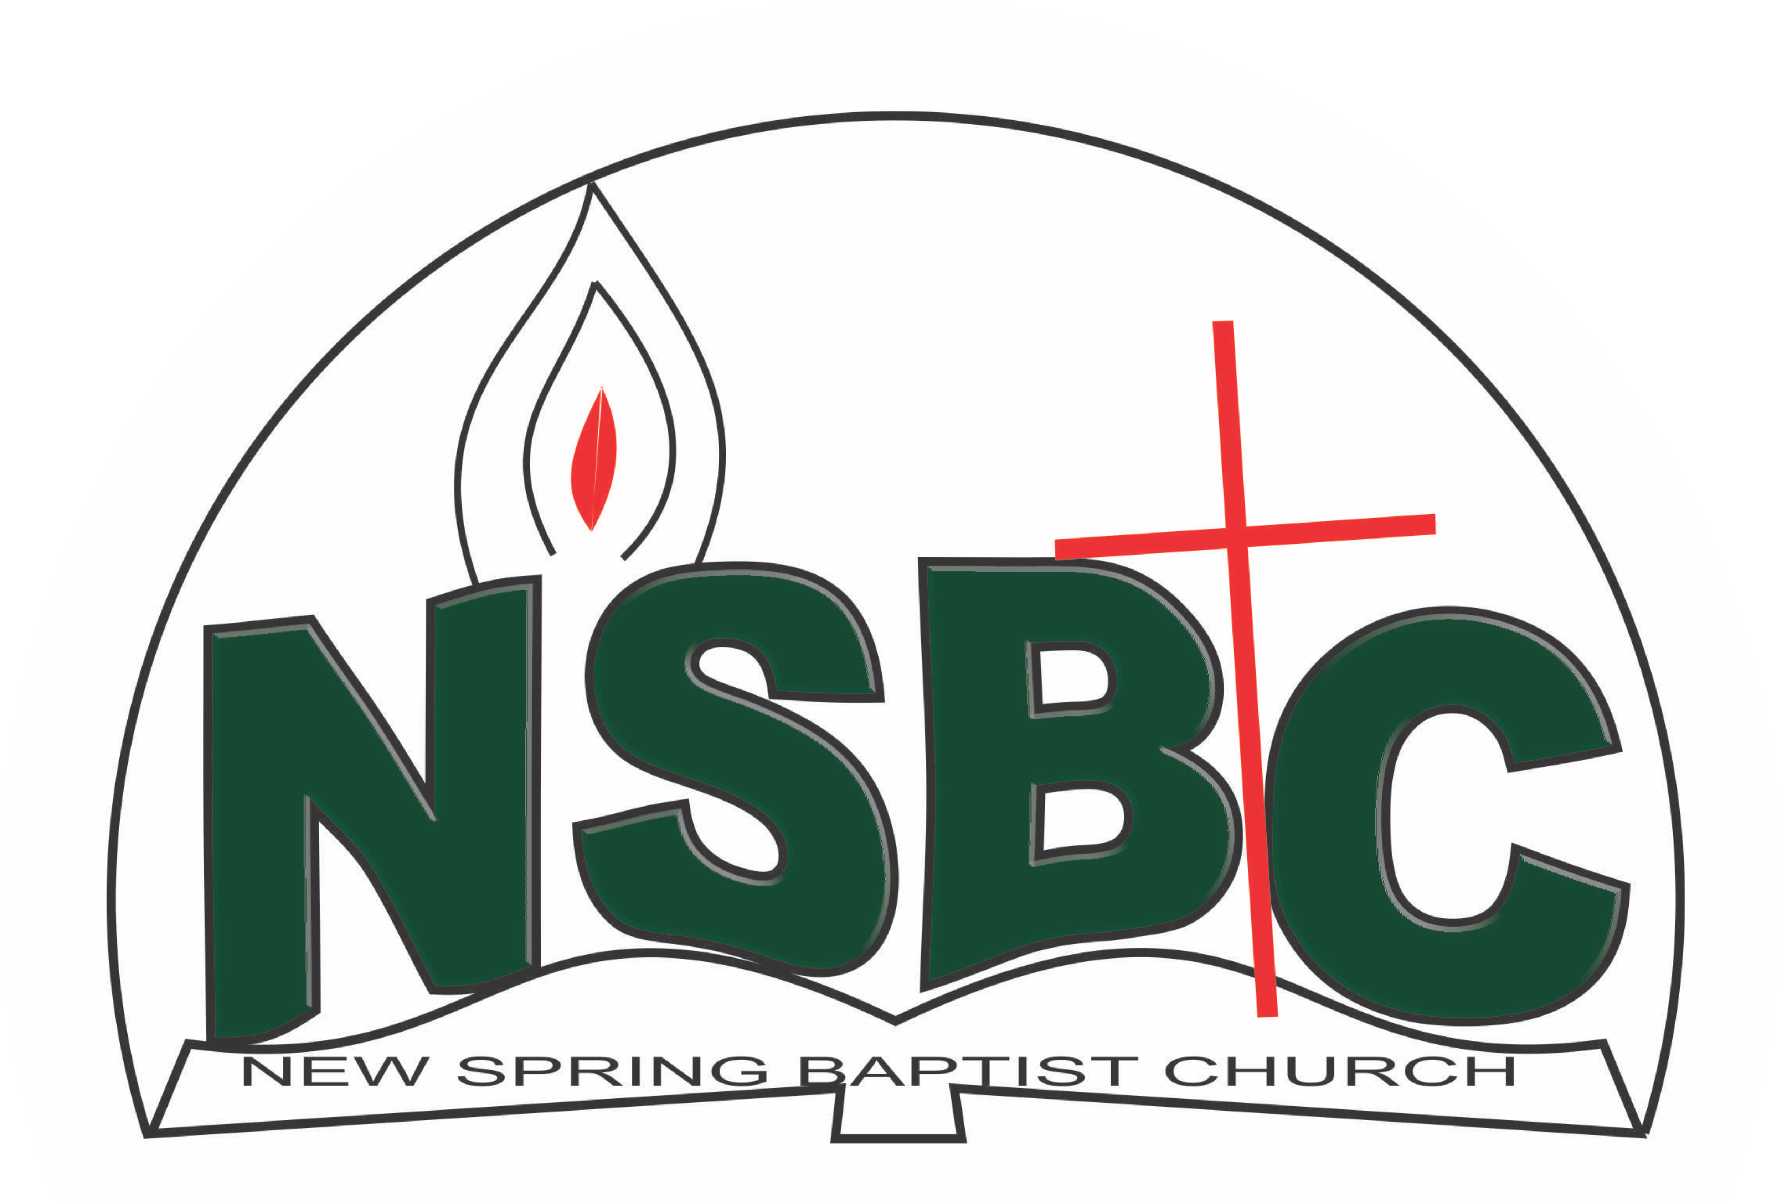

December 27, 2021

Dear Miss Opeyemi Alamu,

Nomination to Serve as a Worker in the Church in 2022.

Calvary greetings in the precious name of our Lord and Saviour Jesus Christ. It is our pleasure to inform you that, at the Church-in-Conference held on December 19, 2021, the Church ratified your nomination to serve in the following areas between January 1 and December 31, 2022:

1. Church usher under the chairmanship of Mr. Nathaniel Oyekunle
2. Member, Health committee under the Chairmanship of Mrs. Nia Olupona

Please refer to the table below for the key functions of each of these roles. Details can be found in the Church constitution. You are strongly encouraged to become familiar with the tasks as stated in the document. There will be an orientation of the Church workers on January 15, 2022at 8:30 a.m. on the church premises. Please ensure you participate in this training.

“Now it is required that those who have been given a trust must prove faithful. I Corinthians 4:2”. May God find you faithful in the task He has assigned to you.

| Domain | Key function of Office, Department or Committee |
| --- | --- |
| Church usher | To provide support to the Church Pastor in guiding members and visitors to appropriate seating locations before and during service |
| Health | The committee is to support the Church Pastor in providing professional guidance to the Church in health-related matters of the Church members. |

Thank you for accepting to serve in this Church.

Yours in His service

Olusayo Okediji Blessed Agboola

Church Secretary Chairman, Nominating Committee